Mona Mohammed

Qatar University

Testing Documentation

# Login Page:

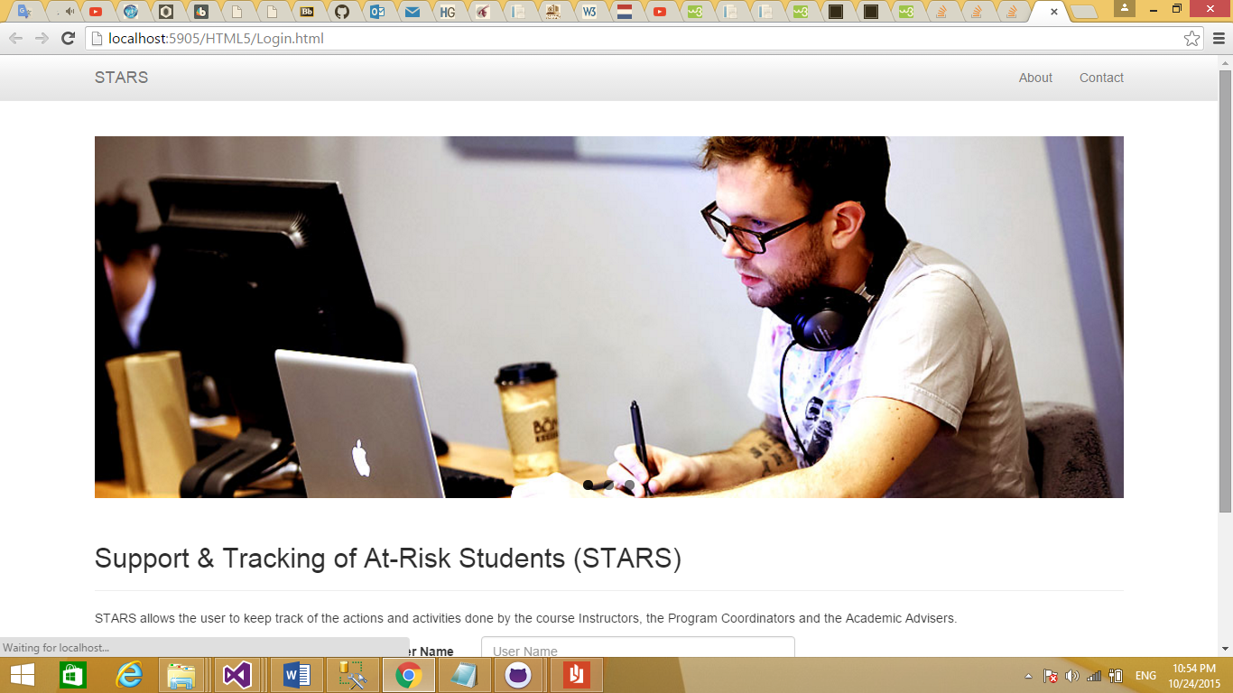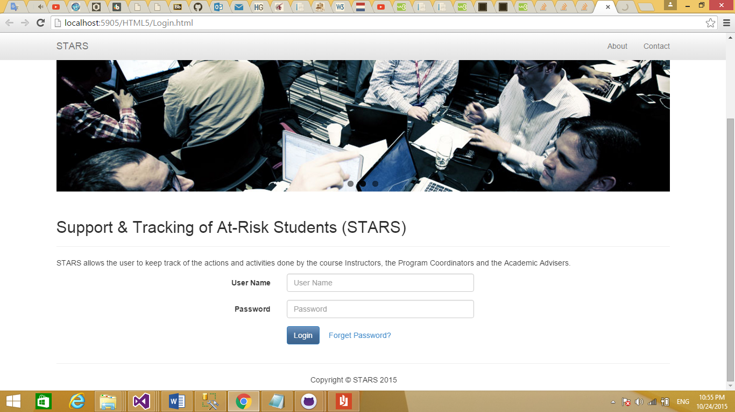

The system has 3 types of users which are:

1. Instructor
2. Coordinator
3. Advisor

Where each one of them has a unique user name and password. After he enters his credentials, the system will take him to the Home page

# Home Page:

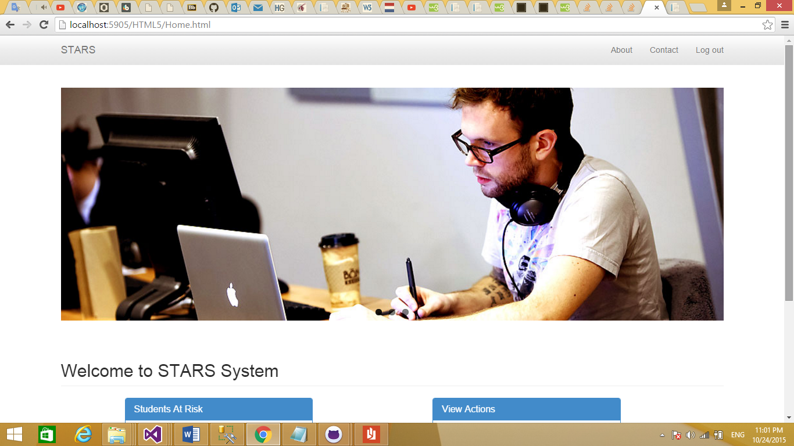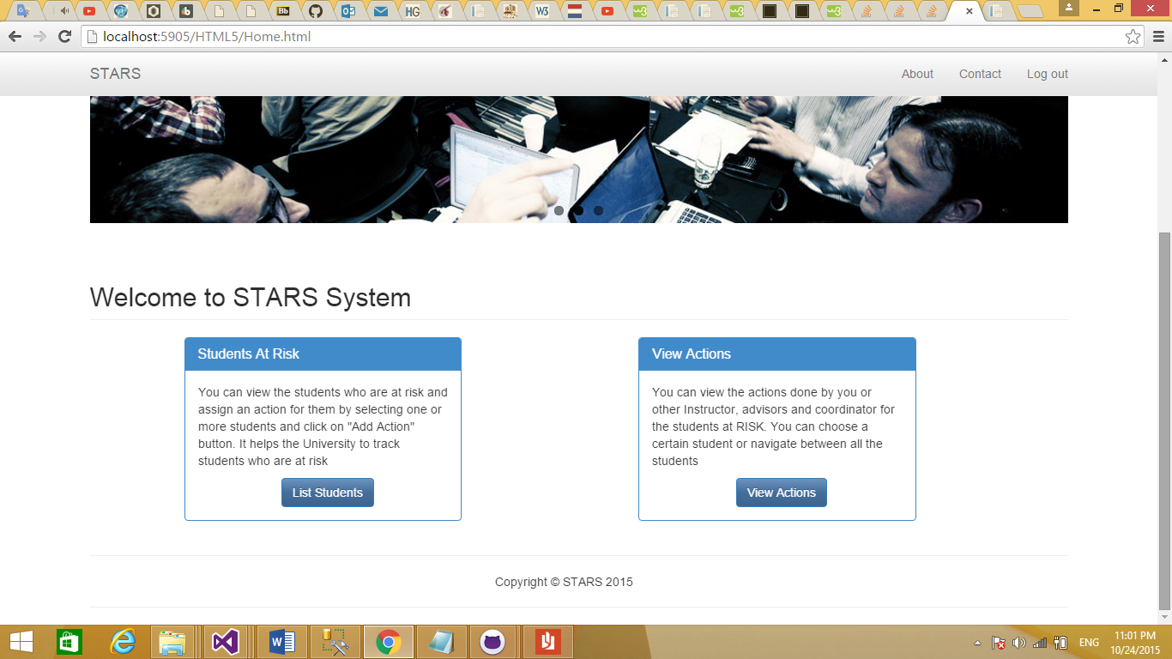

The Home page is showing two types of actions that he can do for at risk students. Either List all students who are at risk to add actions to them or view the actions did before.

By clicking on “List Students” button, the page will show the students who are at risk that teaches by the logged in instructor or having the same program of logged in Advisor or Coordinator.

# List of Students Page:

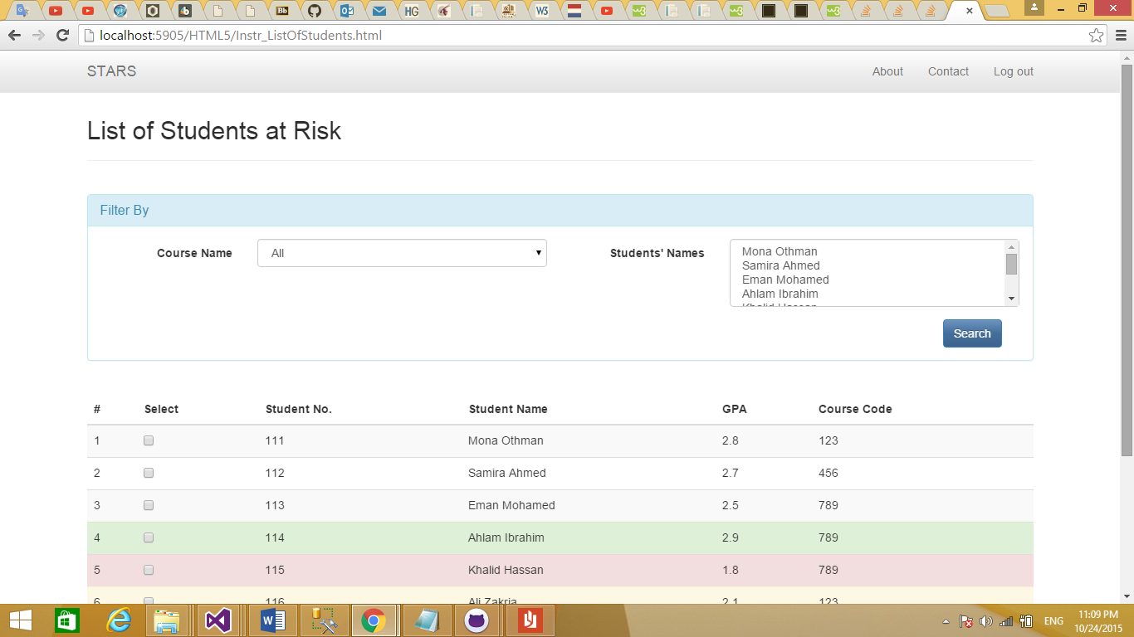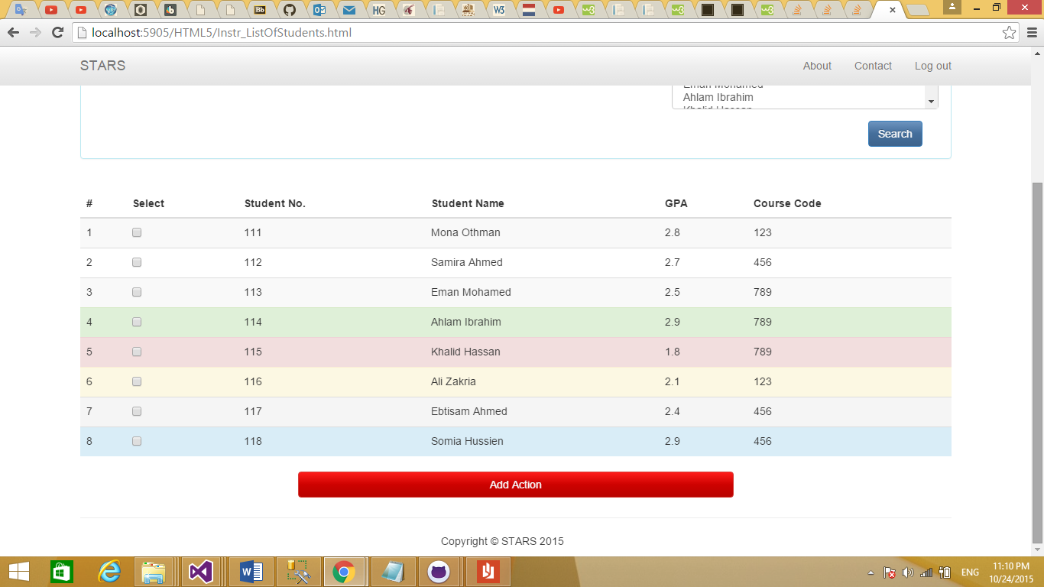

This page shows the list of students who are at risk related to the logged in user as mentioned earlier with the ability to filter based on course or program, and student names. The User can choose one or more students then click on Add Action to add follow-up action for them.

# Add Follow-up Action Page:

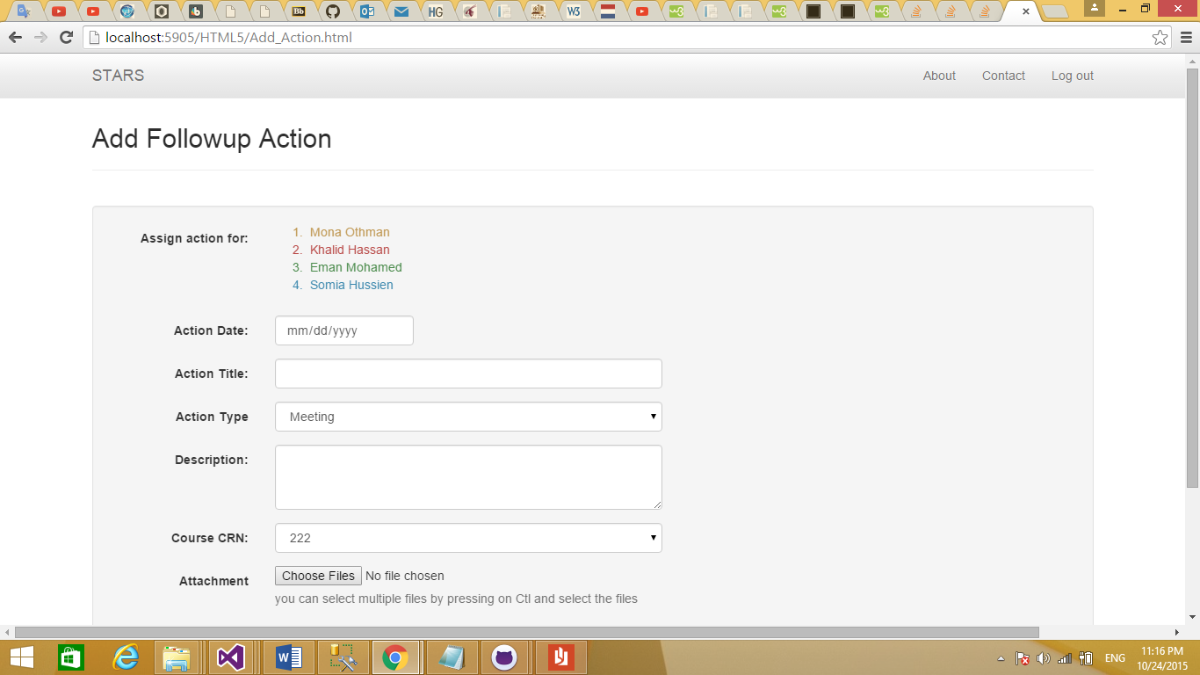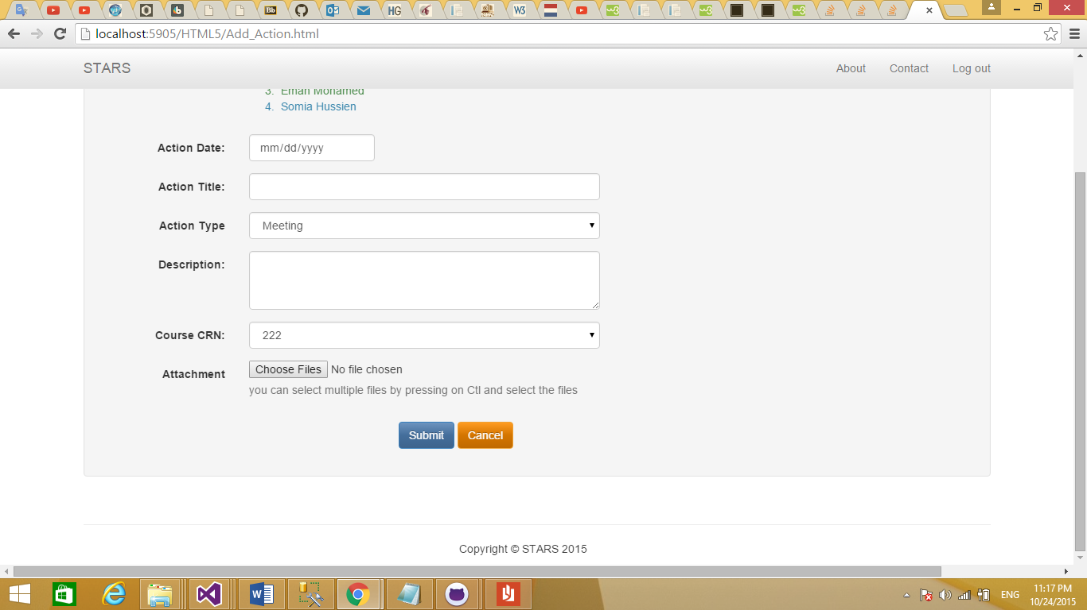

In this page, the user can assign an action to a student or a list of students he chosen before.

To View the added action, we need to go to the home page by clicking on “STARS” link in the top menu, then click on “View Action” button which will take the user to View Action page:

# View Student’s Action Page:

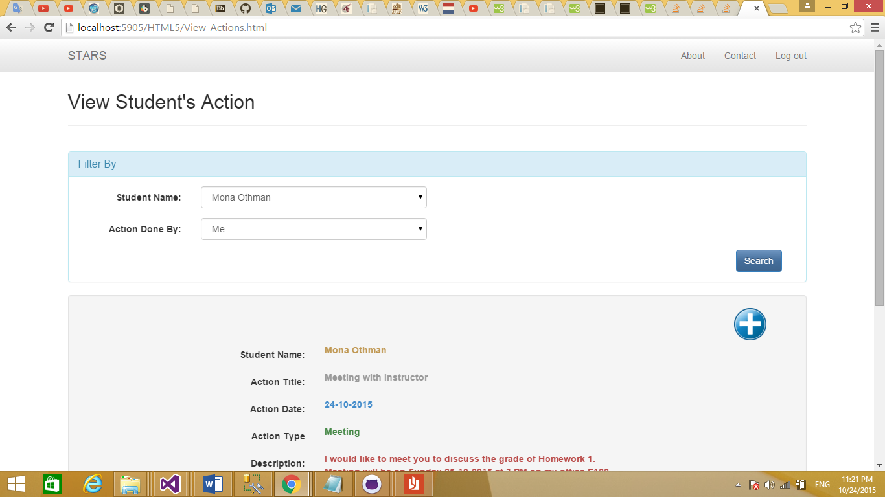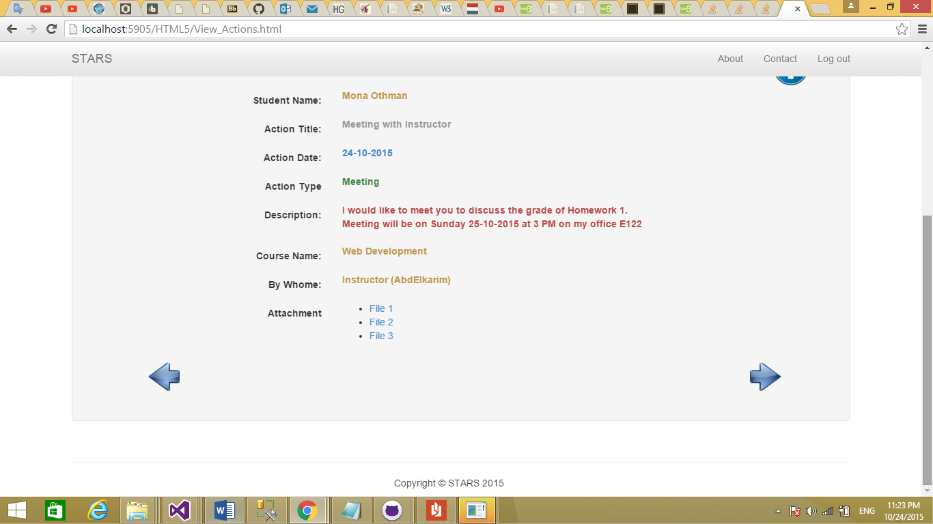

In this page, the user can view student’s actions did by him or by other instructors, coordinators, or advisors and he can easily navigate between the students by using the forward and backward buttons or by choosing the student name from the “Filter By” section. He can also add a new action to the student by clicking on Add icon which will take the user to Add Action page shown earlier.